**Bug Id :01**

**Bug Title:** nextBirthdayCalcualator API is not working as expected when the birth date is February 29

**Description :** The bug is occurring when unit is provided as month, day, week or hour.

**Steps to Reproduce**

Use the below API end point with the mentioned test data

<https://p9fwi1d77e.execute-api.eu-west-1.amazonaws.com/Prod/next-birthday?dateofbirth=1996-02-29&unit=month>

Note: 1996 is a leap year and hence February 29 could be a birthdate

**Expected Result** : {

"message": "31 months left"

}

And status code of 200

**Actual Result** : {

"message": "Internal server error"

}



**Severity:** Major

**Bug Id:02**

**Bug Title:** Response of nextBirthdayCalcualator API when invalid unit is provided is incorrect

**Description :** Success message with message as ‘null’ was returned when unit was provided as ‘**year’**

**Steps to Reproduce**

Use the below API end point with the mentioned test data

<https://p9fwi1d77e.execute-api.eu-west-1.amazonaws.com/Prod/next-birthday?dateofbirth=1996-02-28&unit=year>

**Expected Result** : {

"message": "supported units are day,week,hour,month

}

And status code of 200

**Actual Result** : {

    "message": null

}

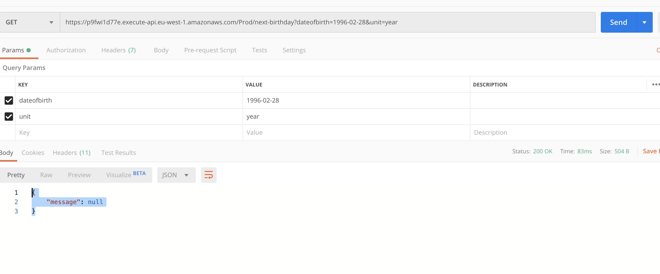

**Severity:** Major

**Bug Id:03**

**Bug Title:** Response from the nextBirthdayCalculator API when birthday is 1 day away is having spelling issue

**Description :** The response is given by the API as ‘1 days left’

*Note*: The same issue occurs when the next birthday is happening within 1 unit of month or week . This means that the response is given as ‘1 months left’ or ‘1 weeks left’

**Steps to Reproduce**

Use the below API end point with the mentioned test data

<https://p9fwi1d77e.execute-api.eu-west-1.amazonaws.com/Prod/next-birthday?dateofbirth=1996-07-19&unit=day>

Note: The date needs to be changed to the currDate()+1 if this is reproduced on a different date.

**Expected Result** : {

"message": "1 day left”

}

And status code of 200

**Actual Result** : {

    "message": "1 days left"

}

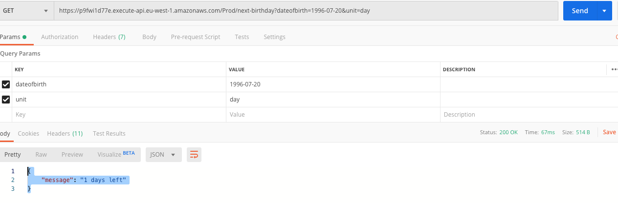

**Severity:** Minor

**Bug Id:04**

**Bug Title:** Incorrect error message when invalid date is provided.

**Description :** When date is provided as ‘31’ for a month which has only 30 days provided, incorrect message is received.

**Steps to Reproduce**

Use the below API end point with the mentioned test data

<https://p9fwi1d77e.execute-api.eu-west-1.amazonaws.com/Prod/next-birthday?dateofbirth=1996-09-31&unit=day>

**Expected Result** : {

"message": "Invalid date”

}

And status code of 200

**Actual Result** : {

    "message": "Please specify dateofbirth in ISO format YYYY-MM-DD"

}

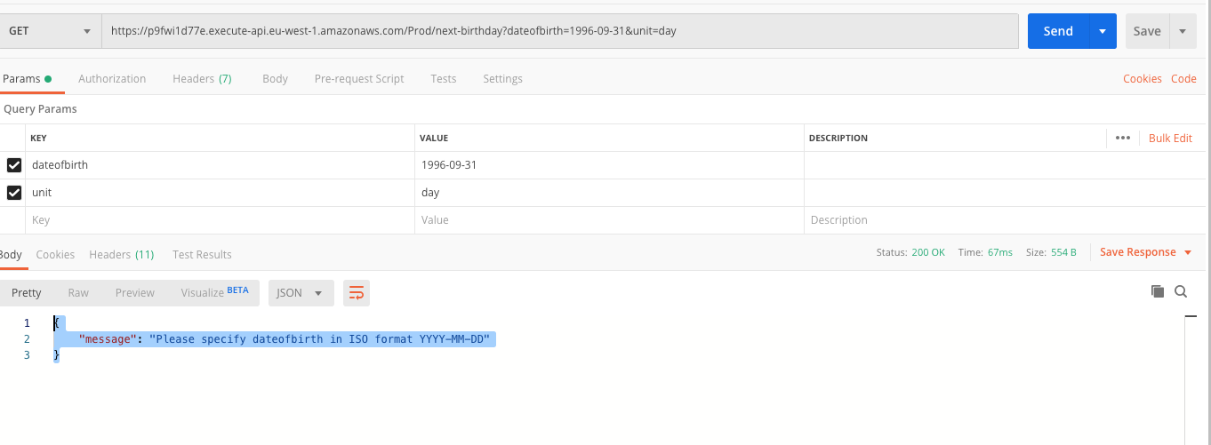

**Severity:** Minor

**Bug Id:05**

**Bug Title:** Invalid calculation of month when birthdate is on a date previous to current date but within the same month

**Description :** Current date is 19 July and the next birthday is given as 1996-07-14 . This means that next birthday should fall on 14 July 2022. This is 11 months and 25 days excluding the date of birthday. But the API gives back response as 12 months.

**Steps to Reproduce**

Use the below API end point with the mentioned test data

<https://p9fwi1d77e.execute-api.eu-west-1.amazonaws.com/Prod/next-birthday?dateofbirth=1996-07-14&unit=month>

Note: Adjust the date in the endpoint to currentdate -5 days if reproduced on a different day

**Expected Result** : { {

    "message": "11 months left"

}

And status code of 200

**Actual Result** : {

    "message": "12 months left"

}

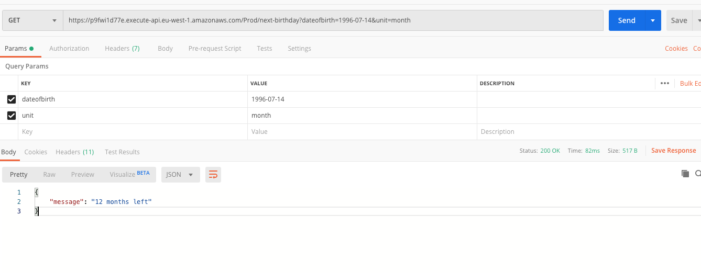

**Severity:** Major